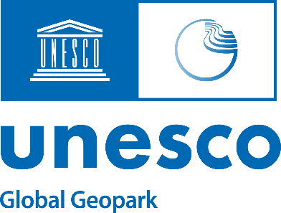

2024 APPLICATION FORM
EVALUATOR FOR UNESCO GLOBAL GEOPARKS

Title
First name
Last name
Gender
Professional position
Affiliation
Academic degree(s)
E-mail
Which languages are you fluent in?
Telephone (please include country code)
Mobile
Address
Post code Country
Current affiliation to UNESCO Global Geopark
(please provide name and country of the Geopark and period)
Position in UNESCO Global Geopark  (please tick the appropriate box) | - Manager  - Representing geoscientist  - Member of the scientific committee
Experience in UNESCO Global Geoparks
(in which capacity, in which Geoparks and also include year(s) of involvement)

Proven professional experience in  (please tick the appropriate boxes) | - Geological heritage  - Geological conservation  - Sustainable development  - Tourism development and promotion  - Environmental issues  - Community engagement  - Public communication of geoscience
Scientific or professional experience in the above-mentioned fields
Previous evaluation and revalidation missions
(please provide the name of the Geopark and the year of the evaluation/revalidation)

By signing this document, I confirm that:

- I have taken note of and will respect the Statutes of the International Geoscience and Geoparks Programme (IGGP) and the Operational Guidelines for UNESCO Global Geoparks in my capacity as an evaluator for UNESCO Global Geoparks.

- I have taken note of and will respect the Terms of Reference for UNESCO Global Geoparks in my capacity as an evaluator for UNESCO Global Geoparks.

- I have taken note of and will respect the Guidelines for UNESCO Global Geopark Field Inspection Missions in my capacity as an evaluator for UNESCO Global Geoparks.
- I have no commercial or business interest, and have not accepted any form of income, from any of the areas presently under evaluation to become a UNESCO Global Geopark or any of the UNESCO Global Geoparks currently undergoing revalidation.
- I will not seek or accept instructions from governments or other authorities.

Signature | Place and Date

Please send your completed application form no later than 15 April 2024 to the UNESCO Global Geopark Secretariat (Kristof Vandenberghe, k.vandenberghe@unesco.org; iggp@unesco.org), and the President of the GGN Association (Nikolaos Zouros, nzour@aegean.gr; secretariat@globalgeoparksnetwork.org), accompanied by their CV and the necessary documentation and references.

